JCT-10
Tabletop Low Speed Centrifuge

Instructions manual

Attention: Before using the machine, please read this Instruction carefully, and keep the Instruction for further reference.

WUHAN JUNJIE ELECTRONICS CO., LTD

TEL：027-87401756 87411993 FAX：027-87411995
WEB：www.whjjbl.com CHINESE WEB：Pathology equipment
E-mail：junjiedianzi@126.com POST CODE：430200
Address: Wuhan East Lake Development Zone, Wuhan Science and Technology Park Industrial Building, North Building

Catalogue
1、Attention for safety.....................................................................................................................2
1.1 Attention for installation and maintenance ............................................................................2
1.2 Attention for electric system.....................................................................................................2
1.3 Attention for fireproofing .........................................................................................................2
1.4 Attention for safe operation .....................................................................................................3
1.5 Attention for safety in chemistry and biology ........................................................................3
2、Symbols and meanings...............................................................................................................4
3、Application and scope................................................................................................................4
4、Work theory................................................................................................................................5
5、Classify and name......................................................................................................................5
5.1 Classify .......................................................................................................................................5
5.2 Name ..........................................................................................................................................5
6、Main technical parameters .......................................................................................................6
7、Features.......................................................................................................................................6
8、The structure of main machine, control board and accessory...............................................7
8.1 The structure of main machine................................................................................................7
8.2 Control board ............................................................................................................................7
8.3 Accessory.....................................................................................................................................9
9、Installation and adjustment.......................................................................................................9
9.1 Installation and its requirements ............................................................................................9
9.1.1 Installation requirements.......................................................................................................9
9.1.2 Install centrifuge ....................................................................................................................9
9.2 Adjust centrifuge .....................................................................................................................10
10、Operation.................................................................................................................................10
10.1 Check the rotor and tube.......................................................................................................10
10.2 Install rotor.............................................................................................................................10
10.3 Add liquid for centrifuge and place it .................................................................................11
10.4 Close the door lid ..................................................................................................................11
10.5 Set speed and time .................................................................................................................11
10.6 Start and stop ...................................................................................................................12
10.7 Take out the centrifugal tube ...............................................................................................12
10.8 Uninstall the rotor .................................................................................................................12
11、Service and maintenance .......................................................................................................13
12、Common trouble and trouble shooting.................................................................................14
13、Transportation and storage....................................................................................................14
13.1 Transportation ......................................................................................................................14
13.2 Storage ...................................................................................................................................14
14、Warranty................................................................................................................................15
15、Packing list..............................................................................................................................16
Attached: Diagram of electric system connection

1、Attention for safety
 Attention for safety clarifies the requirements of safe operation in the instruction manual. Please carefully read it before installation, operation, maintenance and repairing. Understanding the warning and correct operation can avoid the personal injury and the damage of centrifuge.

1.1 Attention for installation and maintenance
·The rotor accessory and package may be placed in the centrifugal chamber. You should open the door lid for checking when installing.
·In the machine maintenance process, the parts that need remove cover may cause electrical shock or personal injury. Ensure that the power has been cut off and the power line has been removed from the socket, and qualified staff manipulates it.
·The replaced part must be consistent with the requirements of this centrifuge.

1.2 Attention for electric system
·To reduce the risk of electric shock, the centrifuge adopts the plug with three points which must connect with the socket with ground lead.
·Make sure if the wall socket is connect with the ground wire. The voltage of power supply must accord with the voltage of centrifuge.
·Don’t use the power adapter from three holes to two holes.
·It is forbidden to use the expanding socket with two lines or all-purpose power adaptor without ground wire.
·Don’t put container with liquid on the centrifuge or around the centrifuge. If the container is knocked over, the liquid will infiltrate into centrifuge and damage the electrical or mechanical parts.

1.3 Attention for fireproofing
·Please use the overload fuse with same model and specification.
·The centrifuge is not designed for the flammable and explosive matters. You cannot make centrifugation for the matters (chloroform, acetaldehyde), and cannot put the matters in the centrifuge or store them around centrifuge within 30cm.
1.4 Attention for safe operation
·Please use the rotor and accessories which are designed for this centrifuge.
·Make sure if the centrifugal chamber is cleaned before operation.
·Make sure if the screw (nut) of the rotor in the centrifugal chamber has been screwed down.
·Not exceed its max speed of rotor during operation.
·Don’t decelerate rotor speed or stop by hand.
·Don’t hold or move centrifuge when rotor is rotating.
·If the glass test tube is cracked in centrifuge chamber, please carefully check and clean the gasket and centrifugal chamber because the glass fragment may have inserted into their surface.
·Don’t open the door lid of centrifuge in the running status.
·The distance between centrifuge and other objects must be kept 30cm during operation. You should not stand around centrifuge within 30cm unless adjusting it. Anything is not allowed to enter into centrifuge during operation.

1.5 Attention for safety in chemistry and biology
· The routine manipulation may include all kinds of liquid and test sample which may be the disease-causing and poisonous matters. The centrifuge can not be manipulated with the matters unless you have toke the protection measures.
·Please pay attention to the liquid explanation in container before operation.
·Be careful of the infectious liquid. If not understanding the provided sample, please at least make sure that they aren’t microbe. You must make further aerosol protection（the suspended speck in the air, such as smoke and fog.）for the easier disease-causing hepatitis virus(B or C), HIV, atypical mycobacteria and the fungus of physical structure.
·The infectious samples must be manipulated according to the manipulating program and method in lab for avoiding expanding disease.
·The spilt matters may produce aerosol（the suspended speck in the air, such as smoke and fog.）, so please pay attention to the warning about aerosol (the suspended speck in the air, such as smoke and fog.)
·Only use the suitable rotor and adaptor. The centrifuge can not be manipulated with disease-causing, poisonous or radioactive matters unless you have toke the protection measures. When the second type of hazardous substances (according to “Laboratory Biosafety Manual” of the World Health Organization.) is manipulated, the air safety level must be monitored. The superior substances require a higher level of safe protection measurements.
·You should follow the environment security and protection requirements when destroying the discarded liquid.

Users have the responsibility to clean and sterilize centrifuge and accessory if you need maintenance service from our company.

2、Symbol and its meanings

No. | Symbol | GB No. | Meanings
1 | ～ | 4706.1 | Alternating current
2 |  | 5465.2 | Power on(general supply)
3 | ○ | 5465.2 | Power off (general supply)
4 |  | 4728.2 | Protective earthing(ground)
5 |  | 4793 | Warning!（see attachment paper）

Form 1
3、Application and scope
JCT-10 low speed centrifuge makes use of centrifugal settling to separate, purify and condense the granule. It can be widely used in the fields of clinical medicine, biochemistry, genetic engineering and radioimmunology. It is ideal equipment for scientific research institute and hospitals.

4、Working Theory
Centrifuge makes use of the strong RCF that centrifuge rotates with high speed in order to accelerate the settling speed of the granule in the liquid, and separate, condense and purify the matters with different settling coefficient and density.

5、Classify and Name
5.1 Classify
·It belongs to Class 1 of medical laboratory equipment according to the management of “The Classified Catalogue of Medical Devices”.
·It belongs to Class 1 of ordinary equipment with protective grounding according to the protection against electric shock.
·It belongs to tabletop centrifuge according to the structure.
·It belongs to low speed centrifuge according to the rotating speed.

5.2 Name

T D Z 4 - W S

tabletop DC brushless motor
low speed
self-balance max.speed identification No.,
unit is 1000r/min.

JCT-10 tabletop low speed centrifuge whose Max.speed is 4×1000r/min, is driven by DC brushless motor.

6、Main technical parameters
Model JCT-10
Max.speed 4000r/min
Max.RCF 2200×g
Max.capacity 24×20mL
Speed Accuracy ±50r/min
Time range 1～99min
Power supply ～220V 50Hz 5A
Noise < 65dB（A）
Dimension 320mm×365mm×280mm （W×D×H）
Package Dimension 390mm×440mm×320mm （W×D×H）
Weight: GW: 20 Kg
Environment requirements:
Temperature: 10℃～35℃ Relative humidity: ≤85%

7、Features
·Microprocessor control
·Touch panel and digital display
·The speed is controlled by PWM with high speed accuracy.
·It is controlled by DC brushless frequency conversion electromotor with low-noise and vibration. It runs without carbon dust pollution, which can meet the requirements of lab.
· Adopt special shock isolator for ideal effect of vibration damping.

8、The structure of main machine and control board and accessories
8.1 The structure of main machine
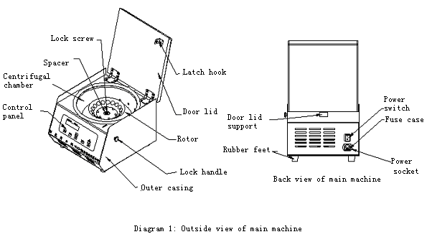

JCT-10 low speed centrifuge is composed of the main machine and accessories. The main machine is composed of case, centrifugal chamber, drive system, control system and the part of manipulation display. The rotor and centrifugal tube(bottle) belong to accessory.

8.2 Control board
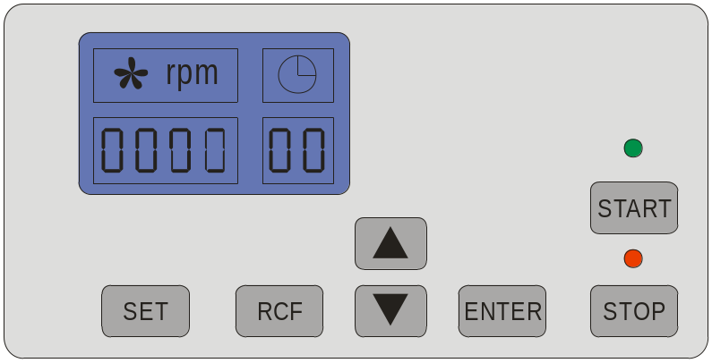
Diagram 2
LCD Display window：Display setup or running parameter of speed, time, rotor No., RCF
SET：Setting key. Set rotor No., speed and time by press this key, and the relative function key flashing.
RCF：RCF display key. This key can display parameter of speed or RCF.
▲: Increase key. Press “▲” to accelerate the setting parameter value.
▼：Decrease key. Press “▼” to decelerate the setting parameter value.
ENTER：Press [ENTER] to confirm the setup working parameter value
JTC-9 display speed and time setting.
Speed setting: Presskey, when “” flashing in display window, you can set it, then press  or key to set running speed (refer to rotor table to ensure the max speed of chosen rotor), press to confirm the setup parameter.
Time setting: Presskey, when “” flashing in display window, you can set it, then press or key to set running time, the working time is display by countdown(the longest working time is 99 min), press to confirm the setup parameter.
START：Press [START] to begin centrifugation after setting and confirming the parameters or repeating the setup parameters last time, and the start indicator light on.
STOP：The key to stop centrifugation. When the centrifuge is working (time isn’t counted down to “0”), you can stop it by manual and the stop indicator light on.
[START] indicator light: The [START] indicator light is on, which means that the centrifuge has started and in the running status.
[STOP] indicator light: The [STOP] indicator light is on which means [STOP] is pressed or the work time is counted down to “0”. The centrifuge is slowing down for stopping or has stopped.

8.3 Accessory
Model | Rotor | Max.speed（r/min） | Capacity (ml) | RCF（×g）
JCT-10 | Angle Rotor | 4000 | 18×10 ml | 2200×g
JCT-10 | Angle Rotor | 4000 | 12×20 ml | 2200×g
JCT-10 | Angle Rotor | 4000 | 4×50 ml | 2200×g
Form 2

9、Installation and adjustment
9.1 Instrument installation and its requirements:
9.1.1 Installation requirements:
Warning: Don’t install centrifuge in the place with flammable and explosive matters. The flammable and explosive gas comes into the running centrifuge, which may lead to fires.
·The centrifuge should be installed on the flat and solid platform.
·The large free space should be kept around the two sides and back of centrifuge for heat dissipation for ventilation.
·It is prohibited to put lab equipment with large heating production and strong vibration around centrifuge.
·The working environment temperature is 10℃ to 35℃, and the relative humidity is no more than ≤85%.
·The requirement of power supply: ～220V 50Hz

9.1.2 Install centrifuge
· Open the outer package, carefully take out the centrifuge with foam package, then put it on the even platform and take off the foam package. The four rubber feet of centrifuge should touch with platform evenly.
· Pull the door lid handle outward, then uplift the door lid until it is hold by door lid support.
· Clear the centrifugal chamber.
·Check the main machine, accessory, attached tools and documents according to the packing list.
·You should confirm that the voltage of the power supply should be consistent with the voltage the centrifuge requires. (Check the marking beside the electric outlet on centrifuge back, and the instrument’s power requirement is AC 220V 50Hz with single phase and three wires.) Connect the power cord(three wires and 10A) to the electric outlet on centrifuge back first, then put the plug on the other end into the external electric supply socket. Press one side marked “I ”on the switch to power on.
·If there are any electronic problems, it should be repaired by the professional technicians.

9.2 Centrifuge adjustment
Warning: It is forbidden to start before the centrifuge chamber is not cleaned. Otherwise, the centrifuge may be damaged.
According to the operation steps of Chapter 10, first run with low speed, and gradually accelerate to the max. speed. If no abnormal phenomenon happens, you have succeeded in adjustment.

10、Operation
10.1Check the rotor and tube: You should carefully check the rotor, tube or test bottle before operation. It is forbidden to use the cracked and damaged rotor, tube or test bottle. Otherwise, all damages should be borne by user.

10.2 Install Rotor: Aim the slot on the bottom of rotor central hole to the horizontal slot on drive shaft, then place the rotor on drive shaft and make the slot in the pin. Then put on a spacer and make the lock screw into tapped hole on the top of drive shaft, tighten it with screw driver.(The rotor has been installed before delivery, and please check whether the lock screw is tighten.)

10.3 Adding liquid and placing of the centrifugal tube: Put centrifugal tubes with adding liquid into the centrifugal tube of rotor and tubes should be placed symmetrically in even number. Otherwise, there will be vibration and noise because of imbalance.

10.4 Close the door lid: Press down the door lid until you hear “clicking” sound which means the door lid pin enter into the hook. Then lift the door lid to check whether it is closed properly. If the door lid can not be opened, it means it is closed properly.

10.5 Set speed and time
（1）、Speed set: Press “SET” key to enter into the speed setting status while the Nixie light on “SPEED/RCF” display window flashes. Then press “▲” or “▼”to set speed for this centrifugation. Centrifuge program has locked its maximum speed according to rotor number. The setting speed should not exceed of its max speed. Finishing above procedures, press key “ENTER” to confirm the setup parameter.
（2）、Time set: Press “SET” key for second time, the Nixie light on “TIME min” display window flashes. Then press “▲” or “▼”to select min for this centrifugation. Press “SET” key for third time, the Nixie light on “TIME seconds” display window flashes. Then press “▲” or “▼”to select seconds for this centrifugation. Selecting the time for this centrifugation (the longest time is 99 min). Time for countdown. Finishing above procedures, press key “ENTER” to confirm the setup parameter.
（3）、After finishing the above two steps, press[START] to run centrifuge
The rotor is not allowed to running in excess of its max speed. Otherwise, all damages caused by above misoperation should be borne by user.

10.6 Start and stop
(1)、Start: Press [START] to run centrifuge and the [START] indicator light is on. You should confirm if the rotor is fixed on the drive shaft before operation and the centrifugal chamber is clean.
(2)、Automatic stop: When time is counted down to “0”, the centrifuge automatically slows down and stops running, and the [STOP] indicator light is on.
(3)、Stop by manual: In the running status (the working time isn’t counted down to “0”), press [STOP] to slow down and stop running, and the [STOP] indicator light is on.

10.7 Take out the rotor: When the rotor stops rotating, press the switch with the mark“○” to cut off the power, keep your right hand on the unlocking handle on the right side of centrifuge and haul out, then open the door lid and take out the centrifugal tubes.

10.8 Uninstall the rotor: When replacing the rotor, you should uninstall the used rotor (unscrewing the bolt with screwdriver and take out the rotor after removing spacer.)
Don’t hold or move the centrifuge during operation.
Don’t open the door lid when rotor is rotating.

11、Service and maintenance
· Please wipe up the rotor with neutral cleaning mixture after taking out for avoiding corrosion and then stock it at dry and ventilated place. Central hole in rotor should be smeared some lubricating oil for protection.
· All action on rotor should be soft, and rotor should be taken out vertically for protecting the shaft.
· Please wipe up the water in centrifuge chamber if it is leaving unused for long time. Some lubricating oil should be smeared on drive shaft for protection.
· Replace fuse
(1) Cut off the power, and unplug the plug the power cord connected with the external electric supply socket. Then draw another end of the power cord connected with the centrifuge.
(2) There is a fuse case equipped on the under part of electric outlet on instrument back. (See figure 3) There is a marking for fuse symbol, and find the V-shape slot on fuse case. (See figure 4) Pull out the fuse case with slotted point screw driver into the V-shape slot.
(3) Take out the damaged fuse and replace it. The model of fuse of the centrifuge is BGXP 5×20 、250V 5A.
(4) Put the fuse case into electric outlet.
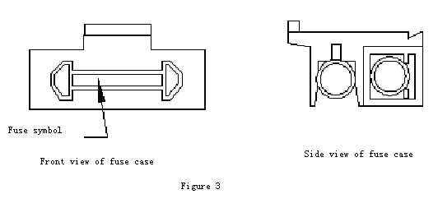

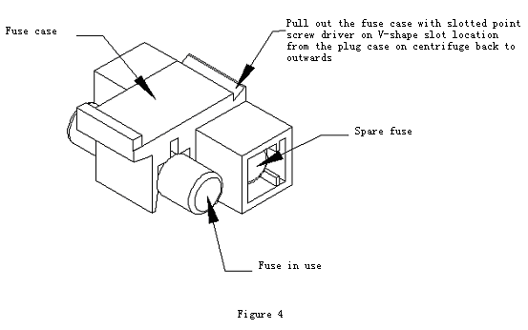

12、The common trouble and trouble shooting
The LCD display window lights on and displays the relative error code when the error/trouble appears.
Error code | Reasons |  | Solution
E6 | Overspeed | Motor drive module fault | Check and replace
E7 | Motor runs without speed. | No power for motor. | Check and replace motor drive module
E7 | Motor runs without speed. | Motor shaft is blocked. | Check and replace motor
Form 3
If the centrifuge still can not work after removing the above several troubles, please contact with our company or service stations designated by our company.

13、Transportation and storage
13.1 Transportation
·You should use the wooden and paper case during long-distance transportation. Put centrifuge with dust cap into the case, and fill with foam or plastic shock absorption materials. It is forbidden to be hit, inverted, rolled and soaked by rain and snow.
·You can directly move the centrifuge in room, but avoid big vibration, hitting and inversion.
13.2 Storage
· If it is leaving unused for long time, you should open the door lid and store it in ventilated, dry and clean room where there is no corrosive, flammable and explosive matters.
· As the technology continuously renews, please consult us if there is something unconformable with this instruction manual.

Warranty
Respected customers,
Thank you for purchase of our company’s products. To protect your legal rights and avoid your worries, we provide warranty service for one year with the main machines. If it is broken under warranty with inartificial reason, we will supply free maintenance service. The customer needs to pay an amount of money if the product has exceeded the warranty period. We will not supply free maintenance if any following matter is happened:
·Exceed of the warranty period or without the warranty card.
·The trouble is caused by wrong installation, operation and maintenance.
·The trouble is caused by the unauthorized uninstalling and repairing by our company.
· The trouble is caused by using the rotor not equipped with this centrifuge.
· The trouble is caused by war, natural disasters or other irresistible factors.

Packing List
Item | No | Name | Quantity | Unit | Remark | Check
Main machine | 1 | JTC-10centrifuge | 1 | set
Option | 2 | Angle rotor 18×10ml | 1 | pc
Option | 3
Option | 4
Option | 5
Attached tool | 1 | Power cord | 1 | pc
Attached tool | 2 | Fuse BGXP 5×20 250V 5A | 5 | pc | Two in fuse case
Attached tool | 3 | Screw driver | 1 | pc
Attached tool | 4
Attached file | 1 | Packing List | 1 | copy
Attached file | 2 | Instruction Manual | 1 | copy
Attached file | 3 | Qualified Certificate | 1 | copy
Attached file | 4

Checker:
Date:

Customer Feedback
User |  | Model
Salesperson |  | Contract NO.
Consignee |  | Date
Degree of satisfaction :
Excellent □ Good□ Poor □ Please mark with“√”
Attention and customer feedback
1.After unpacking the machine,is there any damage?Are the accessories documents and spare parts complete?
2.Are you satisfied with the installer’s introduction of the usage and instructions?
3.Please share with us any other information you would like to help us to improve the product.

Signature ：
Date :

Please fill in the form and give it to the installer or fax or mail it to our company to become our registered user.

Wuhan Junjie Electronics Co.Ltd
Equipment Acceptance Report
Device Name |  |  | Device Model
User’s name |  |  | User’s address
Department |  | Director |  | Tel
Department |  | User |  | Tel
Date of arrival |  |  | Contract No.
Installation | After installation,testing and adjustment, the machine function reached the contract requirements and can be put into use .  Installer’s signature:  Date :
Acceptance  Check | The equipment is well packaged with complete accessories.After installation,testing and adjustment, the buyer prove that each machine function reached the contract requirements and the performance is good and acceptable.  Signature : Hospital’s official seal :  Date :
Address：Chuangye Street 10-A-404, Guanggu, East Lake High-tech Development Zone, Wuhan City
Postcode：430074
Tel: 8627-87401756 / 862787411993 Fax:8627-87411993
Website：http://www.whjjbl.com E-mail： junjiedianzi@126.com

Quality Certificate

Product Name：JCT-10 Tabletop Low Speed Centrifuge

Serial No.：______________________________

This production is tested to be qualified for delivery.

Checker:

Date:

